ALGEBRA 2 Name ___________________________ Per. ____

CONICS TEST B – Show all work. Be sure to label all graphs with key points. NO CALCULATOR.
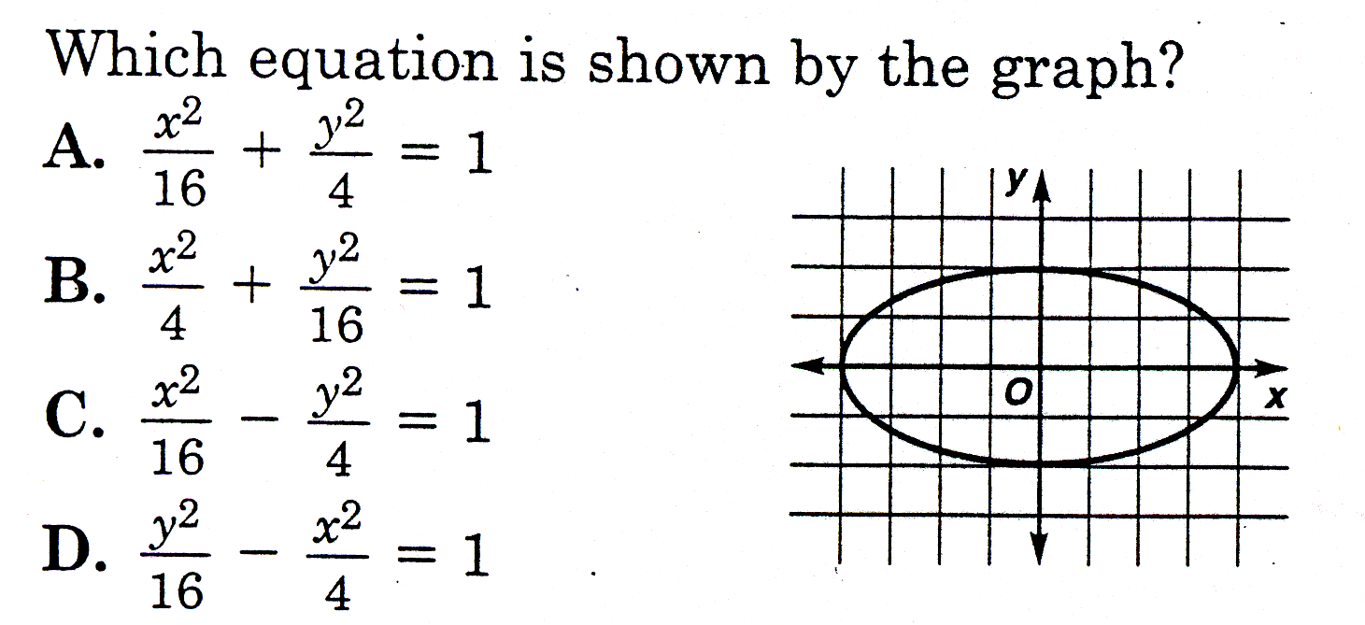
1. 1. ______

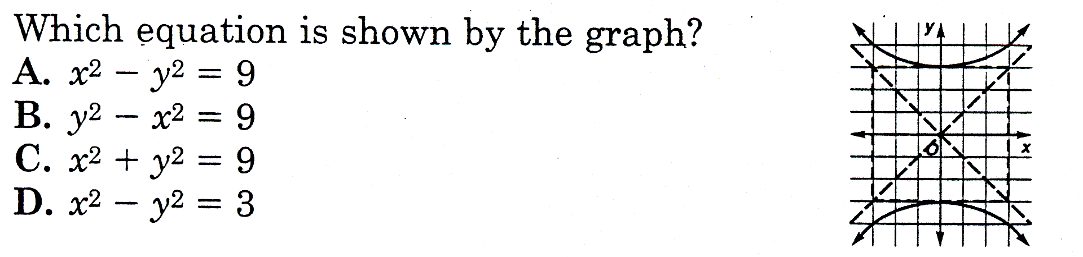
2. 2. ______

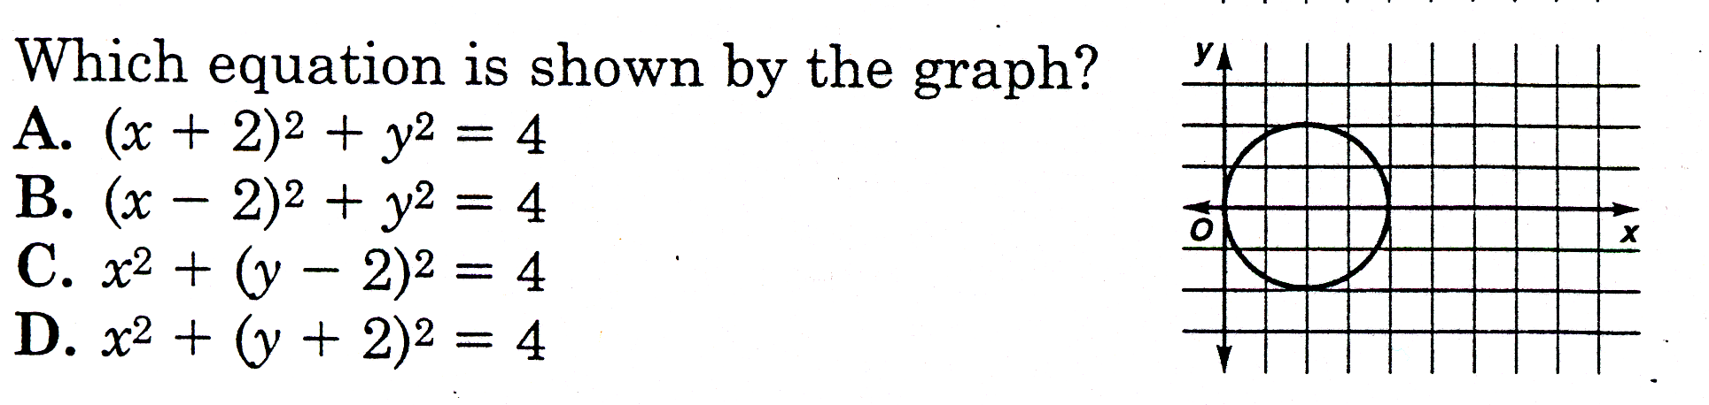
3 3. ______

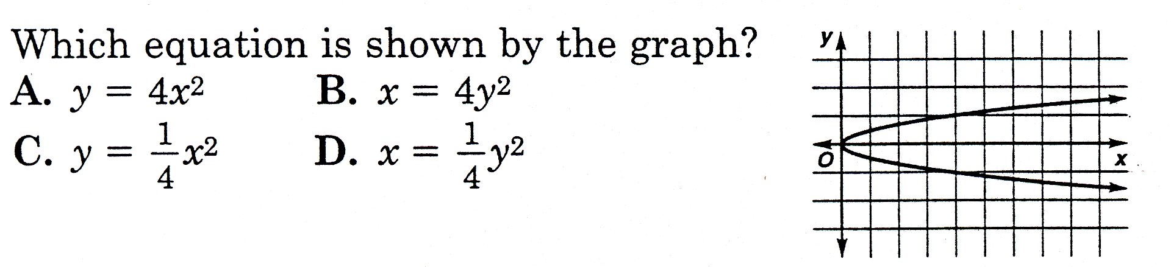
4 4. ______

5. Solve 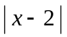 > 6

[A] –4 8 [B] –4 or 8 [C] –4 < < 8 [D] < –4 or > 8 5. ______

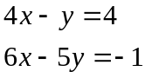
6. What does equal in the solution of the system to the right?

[A] 2 [B] 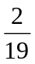 [C] 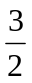 [D] 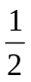 6. ______
7. Graph the system of inequalities: 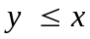
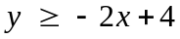
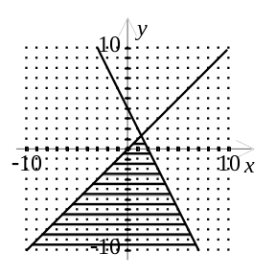
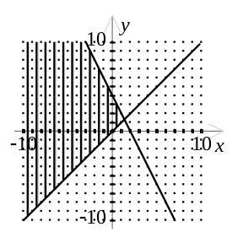
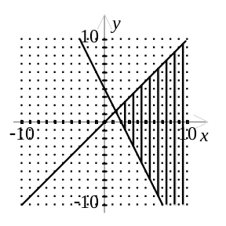
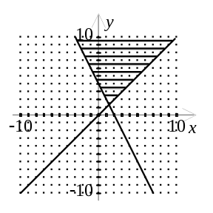
[A] [B] [C] [D] 7. ________

8. What are the solutions to the equation?
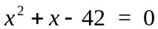

[A] [B]

[C] [D] 8. _________

9. Write the expression as a complex number in standard form. 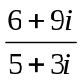

[A] 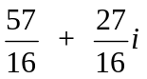 [B] 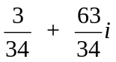 [C] 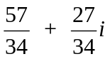 [D] 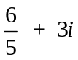 9. ________

10. Simplify 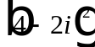

[A] 20 [B] 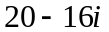 [C] 12 [D] 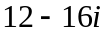 10. ________

11. Which of the following is the equation of the line passing through the points (3, -8) , (-3, 2)?

[A] 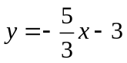 [B] 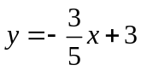 [C] 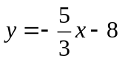 [D] 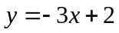 11. _________

12. State whether the transverse axis is horizontal or vertical and find the center of the hyperbola with the equation: 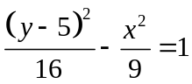.

Center: __________ Transverse Axis: Horizontal Or Vertical

13. Classify each equation as a parabola (P), circle (C), ellipse (E), hyperbola (H), or line (L).
a. 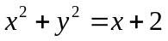 ________
b. 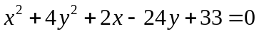 ________
c. 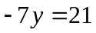 ________
d. 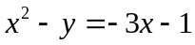 ________
e. 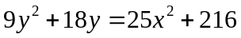 ________

14. Convert to Vertex Form: 15. Convert to Standard Form:
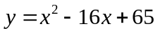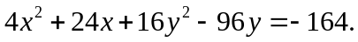

16. Name the vertex, equation of the axis of symmetry 17. For the ellipse with the equation
and the direction the parabola opens for the equation: 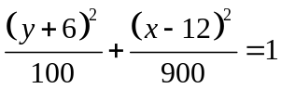 find the:
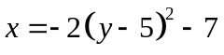
vertex ____________ center: ______________

equation of axis of symmetry __________ length of the major axis: ______________

opens ____________ The major axis is __________________ .
(horizontal or vertical)

18. Write an equation for a circle that has its center at 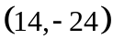 and a radius of 16.

19. Graph the equation. 20. Graph each equation.
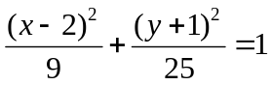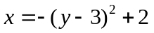
y
x
y
x

21. Graph each equation. 22. Graph each equation.
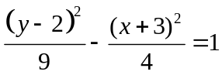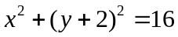
y
x
y
x

16. Write the equation of the conic section shown below.

a) b)

Equation: __________________________ Equation:__________________________

17. Write the equation of the conic section shown below.

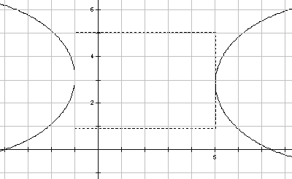
a) b)

Equation: _____________________________ Equation: ___________________________

