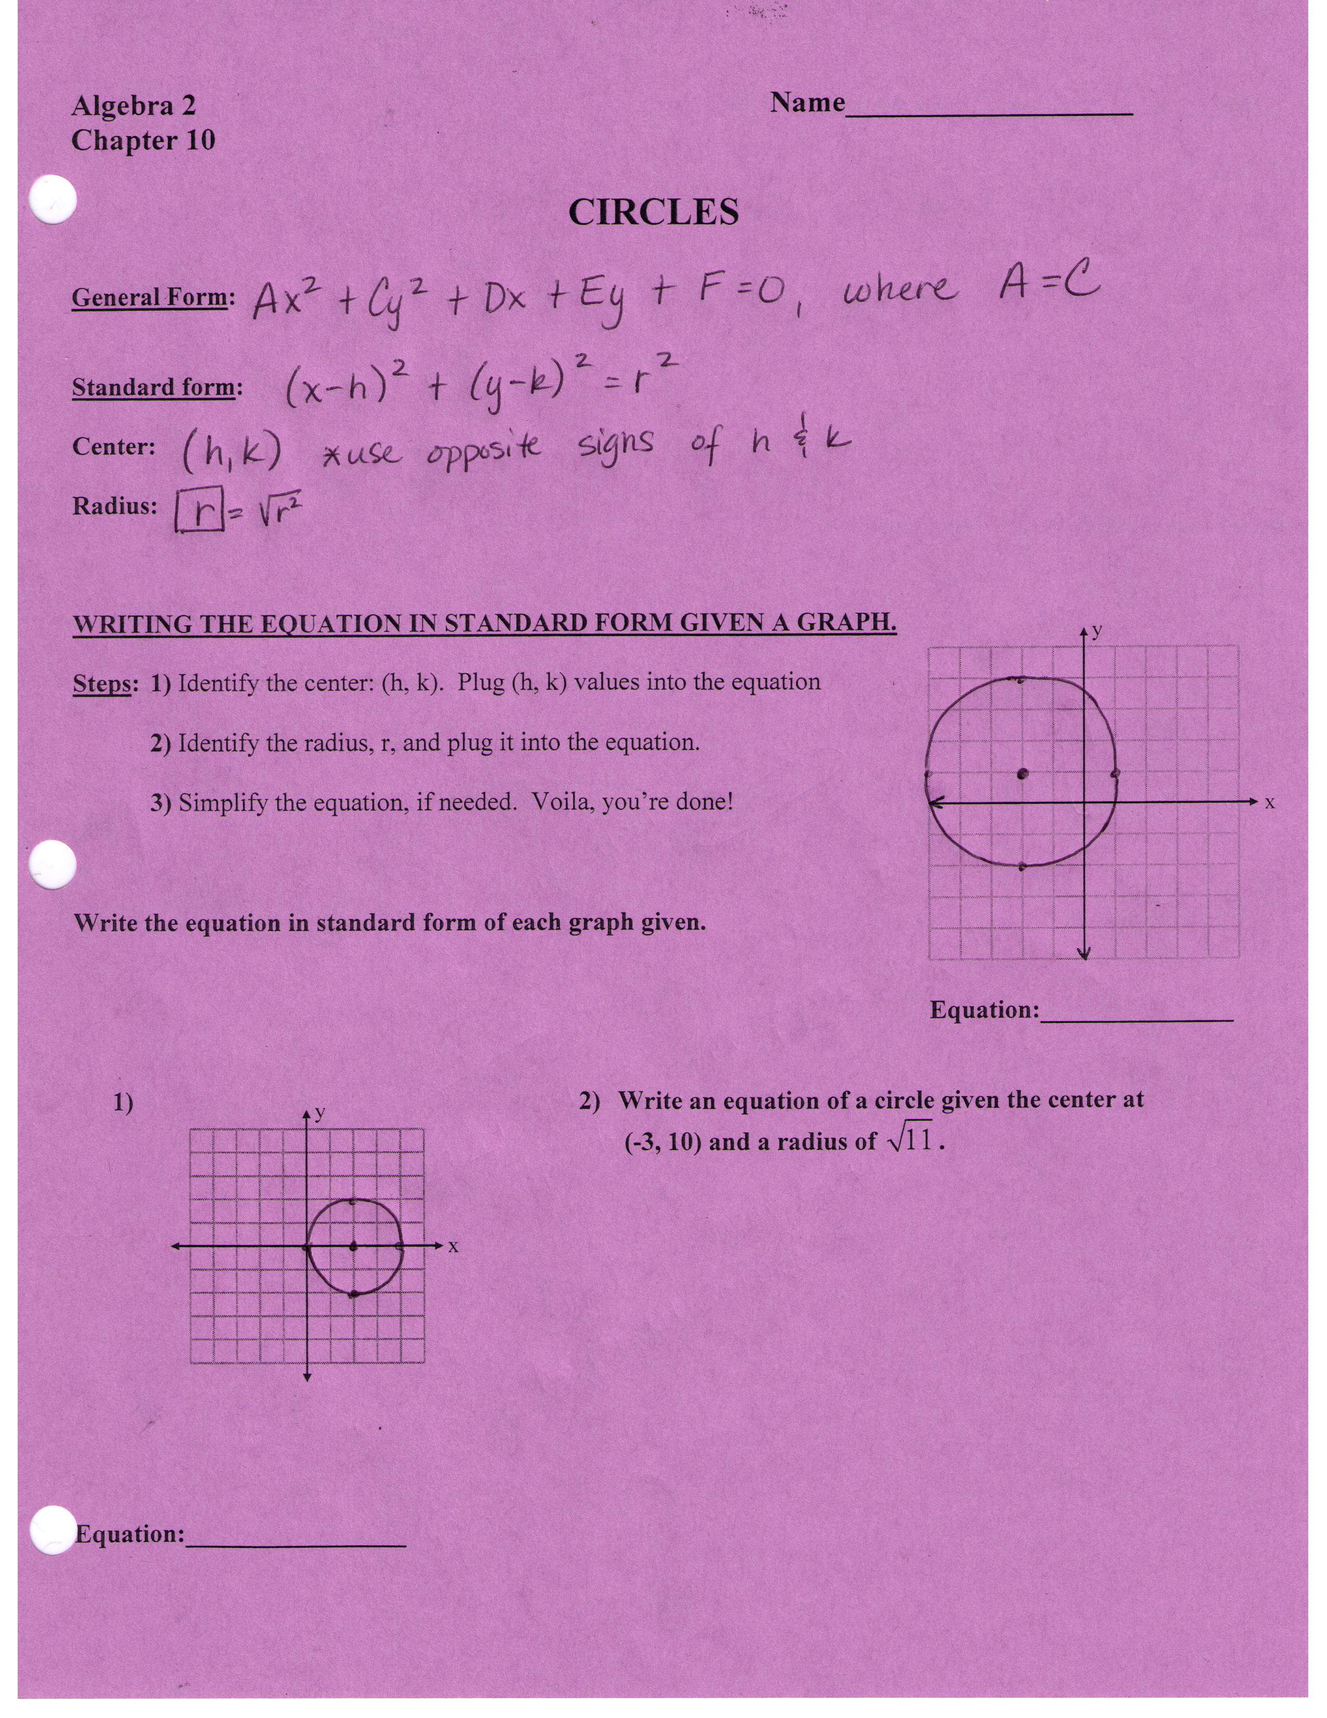
GRAPHING A CIRCLE GIVEN AN EQUATION.

Steps: 1)

2)

Graph the circle from the given equation.

1) 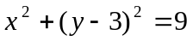 2) 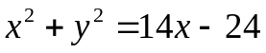
y
x
y
x

3) x² + y² – 4x + 6y + 4 = 0
y
x

