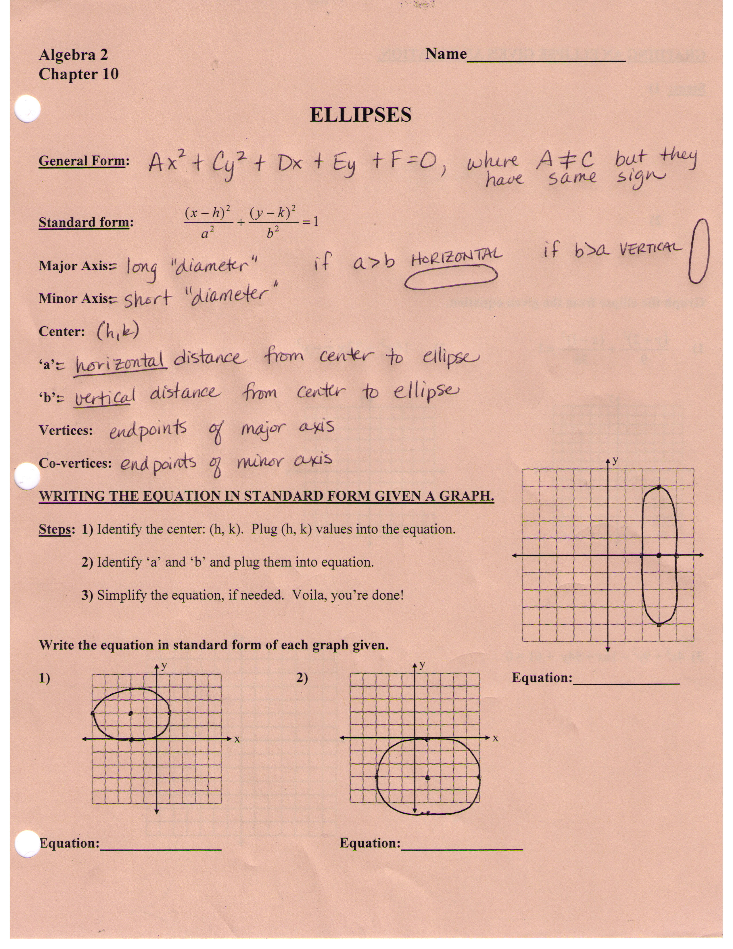
GRAPHING AN ELLIPSE GIVEN AN EQUATION.

Steps: 1)

2)

3)

Graph the ellipse from the given equation.

1) 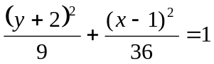 2) 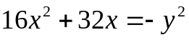

y
x
y
x

y
x

3) 4x² + 9y² – 16x + 54y + 61 = 0

